Servlet API:

The javax.servlet and javax.servlet.http packages represent interfaces and classes for servlet api. Let's see what are the interfaces of javax.servlet package

Interfaces in javax.servlet package
There are many interfaces in javax.servlet package. They are as follows:
- Servlet
- ServletRequest
- ServletResponse
- RequestDispatcher
- ServletConfig
- ServletContext
- SingleThreadModel
- Filter
- FilterConfig
- FilterChain
- ServletRequestListener
- ServletRequestAttributeListener
- ServletContextListener
- ServletContextAttributeListener

Classes in javax.servlet package
There are many classes in javax.servlet package. They are as follows:
- GenericServlet
- ServletInputStream
- ServletOutputStream
- ServletRequestWrapper
- ServletResponseWrapper
- ServletRequestEvent
- ServletContextEvent
- ServletRequestAttributeEvent
- ServletContextAttributeEvent
- ServletException
- UnavailableException

Interfaces in javax.servlet.http package
There are many interfaces in javax.servlet.http package. They are as follows:
- HttpServletRequest
- HttpServletResponse
- HttpSession
- HttpSessionListener
- HttpSessionAttributeListener
- HttpSessionBindingListener
- HttpSessionActivationListener
- HttpSessionContext (deprecated now)

Classes in javax.servlet.http package
There are many classes in javax.servlet.http package. They are as follows:
- HttpServlet
- Cookie
- HttpServletRequestWrapper
- HttpServletResponseWrapper
- HttpSessionEvent
- HttpSessionBindingEvent
- HttpUtils (deprecated now)

Servlet Interface
Servlet interface provides common behaviour to all the servlets.
Servlet interface needs to be implemented for creating any servlet (either directly or indirectly). It provides 3 life cycle methods that are used to initialize the servlet, to service the requests, and to destroy the servlet and 2 non-life cycle methods.

Methods of Servlet interface
There are 5 methods in Servlet interface. The init, service and destroy are the life cycle methods of servlet. These are invoked by the web container.
Method | Description
public void init(ServletConfig config) | initializes the servlet. It is the life cycle method of servlet and invoked by the web container only once.
public void service(ServletRequest request,ServletResponse response) | provides response for the incoming request. It is invoked at each request by the web container.
public void destroy() | is invoked only once and indicates that servlet is being destroyed.
public ServletConfig getServletConfig() | returns the object of ServletConfig.
public String getServletInfo() | returns information about servlet such as writer, copyright, version etc.

Simple Example:
- import java.io.*;
- import javax.servlet.*;

- public class First implements Servlet{
- ServletConfig config=null;

- public void init(ServletConfig config){
- this.config=config;
- System.out.println("servlet is initialized");
- }

- public void service(ServletRequest req,ServletResponse res)
- throws IOException,ServletException{

- res.setContentType("text/html");

- PrintWriter out=res.getWriter();
- out.print("<html><body>");
- out.print("<b>hello simple servlet</b>");
- out.print("</body></html>");

- }
- public void destroy(){System.out.println("servlet is destroyed");}
- public ServletConfig getServletConfig(){return config;}
- public String getServletInfo(){return "copyright 2007-1010";}

- }

We are writing the class which implements Servlet Class and we have to override all the methods present in Servlet interface.

GenericServlet:

public abstract class GenericServlet
extends java.lang.Object
implements Servlet, ServletConfig, java.io.Serializable

Defines a generic, protocol-independent servlet.
GenericServlet implements the Servlet and ServletConfig interfaces. GenericServlet may be directly extended by a servlet, although it's more common to extend a protocol-specific subclass such as HttpServlet.
GenericServlet makes writing servlets easier. It provides simple versions of the lifecycle methods init and destroy and of the methods in the ServletConfig interface. GenericServlet also implements the log method, declared in the ServletContext interface.
To write a generic servlet, you need only override the abstract service method.

HTTPServlet:

public abstract class HttpServlet
extends GenericServlet
implements java.io.Serializable

Provides an abstract class to be subclassed to create an HTTP servlet suitable for a Web site. A subclass of HttpServlet must override at least one method, usually one of these:
- doGet, if the servlet supports HTTP GET requests
- doPost, for HTTP POST requests
- doPut, for HTTP PUT requests
- doDelete, for HTTP DELETE requests
- init and destroy, to manage resources that are held for the life of the servlet
- getServletInfo, which the servlet uses to provide information about itself
There's almost no reason to override the service method. service handles standard HTTP requests by dispatching them to the handler methods for each HTTP request type (the doXXX methods listed above).

Service method in HttpServlet.java file:

607 protected void service(HttpServletRequest req, HttpServletResponse resp)
608 throws ServletException, IOException {
609
610 String method = req.getMethod();
611
612 if (method.equals(METHOD_GET)) {
613 long lastModified = getLastModified(req);
614 if (lastModified == -1) {
615 // servlet doesn't support if-modified-since, no reason
616 // to go through further expensive logic
617 doGet(req, resp);
618 } else {
619 long ifModifiedSince = req.getDateHeader(HEADER_IFMODSINCE);
620 if (ifModifiedSince < (lastModified / 1000 * 1000)) {
621 // If the servlet mod time is later, call doGet()
622 // Round down to the nearest second for a proper compare
623 // A ifModifiedSince of -1 will always be less
624 maybeSetLastModified(resp, lastModified);
625 doGet(req, resp);
626 } else {
627 resp.setStatus(HttpServletResponse.SC_NOT_MODIFIED);
628 }
629 }
630
631 } else if (method.equals(METHOD_HEAD)) {
632 long lastModified = getLastModified(req);
633 maybeSetLastModified(resp, lastModified);
634 doHead(req, resp);
635
636 } else if (method.equals(METHOD_POST)) {
637 doPost(req, resp);
638
639 } else if (method.equals(METHOD_PUT)) {
640 doPut(req, resp);
641
642 } else if (method.equals(METHOD_DELETE)) {
643 doDelete(req, resp);
644
645 } else if (method.equals(METHOD_OPTIONS)) {
646 doOptions(req,resp);
647
648 } else if (method.equals(METHOD_TRACE)) {
649 doTrace(req,resp);
650
651 } else {
652 //
653 // Note that this means NO servlet supports whatever
654 // method was requested, anywhere on this server.
655 //
656
657 String errMsg = lStrings.getString("http.method_not_implemented");
658 Object[] errArgs = new Object[1];
659 errArgs[0] = method;
660 errMsg = MessageFormat.format(errMsg, errArgs);
661
662 resp.sendError(HttpServletResponse.SC_NOT_IMPLEMENTED, errMsg);
663 }
664 }

GenericServlet Class:

GenericServlet class implements Servlet, ServletConfig and Serializable interfaces. It provides the implementaion of all the methods of these interfaces except the service method.
GenericServlet class can handle any type of request so it is protocol-independent.
You may create a generic servlet by inheriting the GenericServlet class and providing the implementation of the service method.

Methods of GenericServlet class
There are many methods in GenericServlet class. They are as follows:
- public void init(ServletConfig config) is used to initialize the servlet.
- public abstract void service(ServletRequest request, ServletResponse response) provides service for the incoming request. It is invoked at each time when user requests for a servlet.
- public void destroy() is invoked only once throughout the life cycle and indicates that servlet is being destroyed.
- public ServletConfig getServletConfig() returns the object of ServletConfig.
- public String getServletInfo() returns information about servlet such as writer, copyright, version etc.
- public void init() it is a convenient method for the servlet programmers, now there is no need to call super.init(config)
- public ServletContext getServletContext() returns the object of ServletContext.
- public String getInitParameter(String name) returns the parameter value for the given parameter name.
- public Enumeration getInitParameterNames() returns all the parameters defined in the web.xml file.
- public String getServletName() returns the name of the servlet object.
- public void log(String msg) writes the given message in the servlet log file.
- public void log(String msg,Throwable t) writes the explanatory message in the servlet log file and a stack trace.

Simple Example:

- import java.io.*;
- import javax.servlet.*;

- public class First extends GenericServlet{
- public void service(ServletRequest req,ServletResponse res)
- throws IOException,ServletException{

- res.setContentType("text/html");

- PrintWriter out=res.getWriter();
- out.print("<html><body>");
- out.print("<b>hello generic servlet</b>");
- out.print("</body></html>");

- }
- }

Here we are writing Servlet that extends GenericServlet Class and we are overriding service method in GenericServlet Class.

HttpServlet class

The HttpServlet class extends the GenericServlet class and implements Serializable interface. It provides http specific methods such as doGet, doPost, doHead, doTrace etc.

Methods of HttpServlet class
There are many methods in HttpServlet class. They are as follows:
- public void service(ServletRequest req,ServletResponse res) dispatches the request to the protected service method by converting the request and response object into http type.
- protected void service(HttpServletRequest req, HttpServletResponse res) receives the request from the service method, and dispatches the request to the doXXX() method depending on the incoming http request type.
- protected void doGet(HttpServletRequest req, HttpServletResponse res) handles the GET request. It is invoked by the web container.
- protected void doPost(HttpServletRequest req, HttpServletResponse res) handles the POST request. It is invoked by the web container.
- protected void doHead(HttpServletRequest req, HttpServletResponse res) handles the HEAD request. It is invoked by the web container.
- protected void doOptions(HttpServletRequest req, HttpServletResponse res) handles the OPTIONS request. It is invoked by the web container.
- protected void doPut(HttpServletRequest req, HttpServletResponse res) handles the PUT request. It is invoked by the web container.
- protected void doTrace(HttpServletRequest req, HttpServletResponse res) handles the TRACE request. It is invoked by the web container.
- protected void doDelete(HttpServletRequest req, HttpServletResponse res) handles the DELETE request. It is invoked by the web container.
- protected long getLastModified(HttpServletRequest req) returns the time when HttpServletRequest was last modified since midnight January 1, 1970 GMT.

Life Cycle of a Servlet (Servlet Life Cycle)

The web container maintains the life cycle of a servlet instance. Let's see the life cycle of the servlet:
- Servlet class is loaded.
- Servlet instance is created.
- init method is invoked.
- service method is invoked.
- destroy method is invoked.

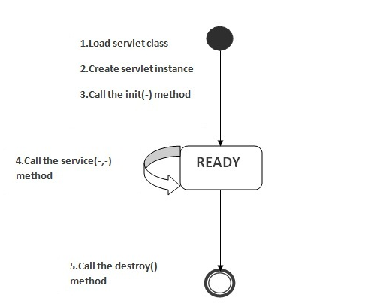

As displayed in the above diagram, there are three states of a servlet: new, ready and end. The servlet is in new state if servlet instance is created. After invoking the init() method, Servlet comes in the ready state. In the ready state, servlet performs all the tasks. When the web container invokes the destroy() method, it shifts to the end state.

1) Servlet class is loaded
The classloader is responsible to load the servlet class. The servlet class is loaded when the first request for the servlet is received by the web container.

2) Servlet instance is created
The web container creates the instance of a servlet after loading the servlet class. The servlet instance is created only once in the servlet life cycle.

3) init method is invoked
The web container calls the init method only once after creating the servlet instance. The init method is used to initialize the servlet. It is the life cycle method of the javax.servlet.Servlet interface. Syntax of the init method is given below:

- public void init(ServletConfig config) throws ServletException

4) service method is invoked
The web container calls the service method each time when request for the servlet is received. If servlet is not initialized, it follows the first three steps as described above then calls the service method. If servlet is initialized, it calls the service method. Notice that servlet is initialized only once. The syntax of the service method of the Servlet interface is given below:

- public void service(ServletRequest request, ServletResponse response)
- throws ServletException, IOException

5) destroy method is invoked
The web container calls the destroy method before removing the servlet instance from the service. It gives the servlet an opportunity to clean up any resource for example memory, thread etc. The syntax of the destroy method of the Servlet interface is given below:

- public void destroy()

Creating a Servlet:

1)Create a directory structures
The directory structure defines that where to put the different types of files so that web container may get the information and respond to the client. The Sun Microsystem defines a unique standard to be followed by all the server vendors. Let's see the directory structure that must be followed to create the servlet.

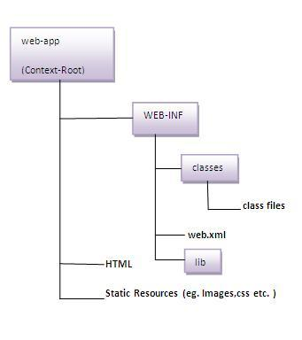

As you can see that the servlet class file must be in the classes folder. The web.xml file must be under the WEB-INF folder.

2)Create a Servlet
There are three ways to create the servlet.
- By implementing the Servlet interface
- By inheriting the GenericServlet class
- By inheriting the HttpServlet class
The HttpServlet class is widely used to create the servlet because it provides methods to handle http requests such as doGet(), doPost, doHead() etc.
In this example we are going to create a servlet that extends the HttpServlet class. In this example, we are inheriting the HttpServlet class and providing the implementation of the doGet() method. Notice that get request is the default request.

- import javax.servlet.http.*;
- import javax.servlet.*;
- import java.io.*;
- public class DemoServlet extends HttpServlet{
- public void doGet(HttpServletRequest req,HttpServletResponse res)
- throws ServletException,IOException
- {
- res.setContentType("text/html");//setting the content type
- PrintWriter pw=res.getWriter();//get the stream to write the data

- //writing html in the stream
- pw.println("<html><body>");
- pw.println("Welcome to servlet");
- pw.println("</body></html>");

- pw.close();//closing the stream
- }}

3)Compile the servlet
For compiling the Servlet, jar file is required to be loaded. Different Servers provide different jar files:

Jar file | Server
1) servlet-api.jar | Apache Tomacat
2) weblogic.jar | Weblogic
3) javaee.jar | Glassfish
4) javaee.jar | JBoss

Two ways to load the jar file
- set classpath
- paste the jar file in JRE/lib/ext folder
Put the java file in any folder. After compiling the java file paste the class file of servlet in WEB-INF/classes folder.

4)Create the deployment descriptor:
The deployment descriptor is an xml file, from which Web Container gets the information about the servet to be invoked. The web container uses the Parser to get the information from the web.xml file. There are many xml parsers such as SAX, DOM and Pull. There are many elements in the web.xml file. Here is given some necessary elements to run the simple servlet.
web.xml file

- <web-app>

- <servlet>
- <servlet-name>sonoojaiswal</servlet-name>
- <servlet-class>DemoServlet</servlet-class>
- </servlet>

- <servlet-mapping>
- <servlet-name>sonoojaiswal</servlet-name>
- <url-pattern>/welcome</url-pattern>
- </servlet-mapping>

- </web-app>

Description of the elements of web.xml file
There are too many elements in the web.xml file. Here is the illustration of some elements that is used in the above web.xml file. The elements are as follows:

<web-app> represents the whole application.
<servlet> is sub element of <web-app> and represents the servlet.
<servlet-name> is sub element of <servlet> represents the name of the servlet.
<servlet-class> is sub element of <servlet> represents the class of the servlet.
<servlet-mapping> is sub element of <web-app>. It is used to map the servlet.
<url-pattern> is sub element of <servlet-mapping>. This pattern is used at client side to invoke the servlet.

5)Start the Server
To start Apache Tomcat server, double click on the startup.bat file under apachetomcat/bin folder.

Simple Life Cycle Of Servlet:

A Servlet cannot run as standalone (as it never has a main method). There's a Servlet Lifecycle that Servlet follows.

A Servlet needs to be deployed on the Servlet Container. A Servlet Container is a container that receives a request from the client, retrieves the Servlet that maps the request and passes the request, and the response returned from the Servlet is then translated to a response back to the end user.

Life Cycle:

The lifecycle of a servlet is controlled by the container in which the servlet has been deployed. When a request is mapped to a servlet, the container performs the following steps.

a) If an instance of the servlet does not exist, the web container
1) Loads the servlet class.
2) Creates an instance of the servlet class.
3) Initializes the servlet instance by calling the *init* method.
b) Invokes the service method, passing request and response objects.
c) If it needs to remove the Servlet, the container finalizes the Servlet by calling the Servlets destroy method.
The web container is responsible to handle the request. Let's see how it handles the request.
- maps the request with the Servlet in the web.xml file.
- creates request and response objects for this request
- calls the service method on the thread
- The public service method internally calls the protected service method
- The protected service method calls the doGet method depending on the type of request.
- The doGet method generates the response and it is passed to the client.
- After sending the response, the web container deletes the request and response objects. The thread is contained in the thread pool or deleted depends on the server implementation.

public service method
The public service method converts the ServletRequest object into the HttpServletRequest type and ServletResponse object into the HttpServletResponse type. Then, calls the service method passing these objects.

- public void service(ServletRequest req, ServletResponse res)
- throws ServletException, IOException
- {
- HttpServletRequest request;
- HttpServletResponse response;
- try
- {
- request = (HttpServletRequest)req;
- response = (HttpServletResponse)res;
- }
- catch(ClassCastException e)
- {
- throw new ServletException("non-HTTP request or response");
- }
- service(request, response);
- }

protected service method
The protected service method checks the type of request, if request type is get, it calls doGet method, if request type is post, it calls doPost method, so on. Let's see the internal code:
- protected void service(HttpServletRequest req, HttpServletResponse resp)
- throws ServletException, IOException
- {
- String method = req.getMethod();
- if(method.equals("GET"))
- {
- long lastModified = getLastModified(req);
- if(lastModified == -1L)
- {
- doGet(req, resp);
- }
- ....
- //rest of the code
- }
- }

ServletRequest Interface

An object of ServletRequest is used to provide the client request information to a servlet such as content type, content length, parameter names and values, header informations, attributes etc.

Methods of ServletRequest interface
There are many methods defined in the ServletRequest interface. Some of them are as follows:

Method | Description
public String getParameter(String name) | is used to obtain the value of a parameter by name.
public String[] getParameterValues(String name) | returns an array of String containing all values of given parameter name. It is mainly used to obtain values of a Multi select list box.
java.util.Enumeration getParameterNames() | returns an enumeration of all of the request parameter names.
public int getContentLength() | Returns the size of the request entity data, or -1 if not known.
public String getCharacterEncoding() | Returns the character set encoding for the input of this request.
public String getContentType() | Returns the Internet Media Type of the request entity data, or null if not known.
public ServletInputStream getInputStream() throws IOException | Returns an input stream for reading binary data in the request body.
public abstract String getServerName() | Returns the host name of the server that received the request.
public int getServerPort() | Returns the port number on which this request was received.

Pre initializing the Servlet:
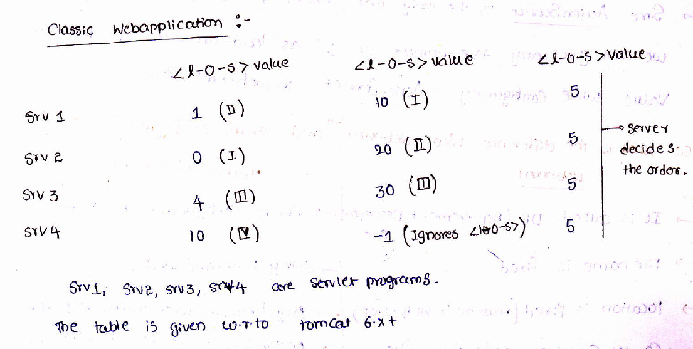

Usually, a servlet container does not initialize the servlets as soon as it starts up. It initializes
a servlet when it receives a request for that servlet for the first time. This is called lazy loading. Although this process greatly improves the startup time of the Servlet container, it has a drawback. If the servlet performs many tasks at the time of initialization, such as caching static data from a database on initialization, the client that sends the first request will have a poor response time. In many cases, this is unacceptable. The servlet specification defines the <load-on-startup> element, which can be specified in the deployment descriptor to make the servlet container load and initialize the servlet as soon as it starts up. This process of loading a servlet before any request comes in is called preloading, or preinitializing, a servlet.

The value of the <load-on-startup> determines the order of loading the servlets by the container. The lesser the value the earlier it starts.
-->If the value is one(1), such servlets has the highest priority of loading the servlet by the container.
-->If the value is zero (0), this has got the least priority and this servlet will be the last to be loaded during the container startup .
-->If two or more servlets have the same value, the servlets in my case (tomcat 5), loaded in the reverse order of declaration in the web.xml.
-->If the value of the startup is negative, or the web.xml doesnot mention this element, then the container decides when to load this servlet.

The container will however load such servlets whenever a request comes in.

Deployment descriptor:
A web application's deployment descriptor describes the classes, resources and configuration of the application and how the web server uses them to serve web requests. When the web server receives a request for the application, it uses the deployment descriptor to map the URL of the request to the code that ought to handle the request.
The deployment descriptor is a file named web.xml. It resides in the app's WAR under the WEB-INF/ directory. The file is an XML file whose root element is <web-app>.
web.xml defines mappings between URL paths and the servlets that handle requests with those paths. The web server uses this configuration to identify the servlet to handle a given request and call the class method that corresponds to the request method (e.g. the doGet() method for HTTP GET requests).
To map a URL to a servlet, you declare the servlet with the <servlet> element, then define a mapping from a URL path to a servlet declaration with the <servlet-mapping> element.
The <servlet> element declares the servlet, including a name used to refer to the servlet by other elements in the file, the class to use for the servlet, and initialization parameters. You can declare multiple servlets using the same class with different initialization parameters. The name for each servlet must be unique across the deployment descriptor.
A deployment descriptor (DD) refers to a configuration file for an artifact that is deployed to some container/engine.
In the Java Platform, Enterprise Edition, a deployment descriptor describes how a component, module or application (such as a web application or enterprise application) should be deployed.^{[1]} It directs a deployment tool to deploy a module or application with specific container options, security settings and describes specific configuration requirements. XML is used for the syntax of these deployment descriptor files.
For web applications, the deployment descriptor must be called web.xml and must reside in the WEB-INF directory in the web application root. For Java EE applications, the deployment descriptor must be named application.xml and must be placed directly in the META-INF directory at the top level of the application .ear file.

RequestDispatcher Interface
The RequestDispacher interface provides the facility of dispatching the request to another resource it may be html, servlet or jsp.This interface can also be used to include the content of antoher resource also. It is one of the way of servlet collaboration.
There are two methods defined in the RequestDispatcher interface.

Methods of RequestDispatcher interface
The RequestDispatcher interface provides two methods. They are:
- public void forward(ServletRequest request,ServletResponse response)throws ServletException,java.io.IOException:Forwards a request from a servlet to another resource (servlet, JSP file, or HTML file) on the server.
- public void include(ServletRequest request,ServletResponse response)throws ServletException,java.io.IOException:Includes the content of a resource (servlet, JSP page, or HTML file) in the response.

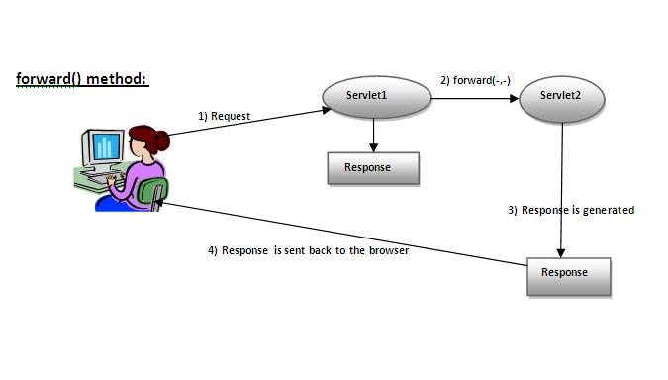
As you see in the above figure, response of second servlet is sent to the client. Response of the first servlet is not displayed to the user.

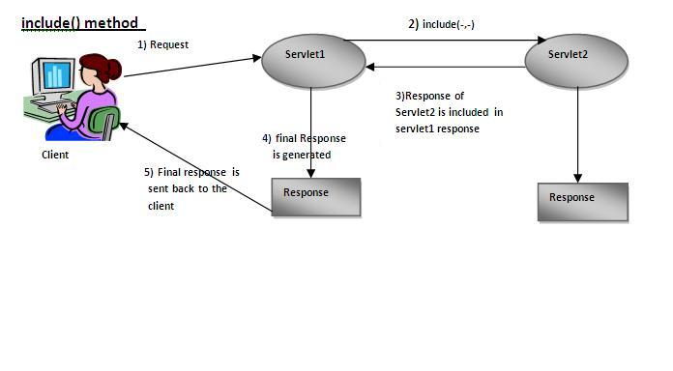
As you can see in the above figure, response of second servlet is included in the response of the first servlet that is being sent to the client.

How to get the object of RequestDispatcher
The getRequestDispatcher() method of ServletRequest interface returns the object of RequestDispatcher. Syntax:

Syntax of getRequestDispatcher method

- public RequestDispatcher getRequestDispatcher(String resource);

xample of using getRequestDispatcher method

- RequestDispatcher rd=request.getRequestDispatcher("servlet2");
- //servlet2 is the url-pattern of the second servlet

- rd.forward(request, response);//method may be include or forward

Example of RequestDispatcher interface
In this example, we are validating the password entered by the user. If password is servlet, it will forward the request to the WelcomeServlet, otherwise will show an error message: sorry username or password error!. In this program, we are cheking for hardcoded information. But you can check it to the database also that we will see in the development chapter. In this example, we have created following files:
- index.html file: for getting input from the user.
- Login.java file: a servlet class for processing the response. If password is servet, it will forward the request to the welcome servlet.
- WelcomeServlet.java file: a servlet class for displaying the welcome message.
- web.xml file: a deployment descriptor file that contains the information about the servlet.
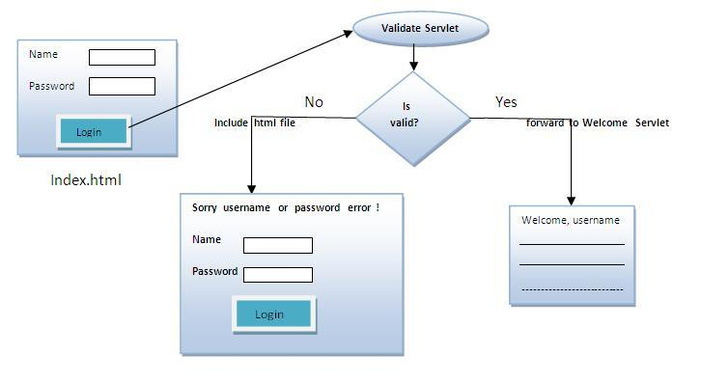

index.html

- <form action="servlet1" method="post">
- Name:<input type="text" name="userName"/><br/>
- Password:<input type="password" name="userPass"/><br/>
- <input type="submit" value="login"/>
- </form>

Login.java

- import java.io.*;
- import javax.servlet.*;
- import javax.servlet.http.*;

- public class Login extends HttpServlet {

- public void doPost(HttpServletRequest request, HttpServletResponse response)
- throws ServletException, IOException {

- response.setContentType("text/html");
- PrintWriter out = response.getWriter();

- String n=request.getParameter("userName");
- String p=request.getParameter("userPass");

- if(p.equals("servlet"){
- RequestDispatcher rd=request.getRequestDispatcher("servlet2");
- rd.forward(request, response);
- }
- else{
- out.print("Sorry UserName or Password Error!");
- RequestDispatcher rd=request.getRequestDispatcher("/index.html");
- rd.include(request, response);

- }
- }

- }

WelcomeServlet.java

- import java.io.*;
- import javax.servlet.*;
- import javax.servlet.http.*;

- public class WelcomeServlet extends HttpServlet {

- public void doPost(HttpServletRequest request, HttpServletResponse response)
- throws ServletException, IOException {

- response.setContentType("text/html");
- PrintWriter out = response.getWriter();

- String n=request.getParameter("userName");
- out.print("Welcome "+n);
- }

- }

web.xml

- <web-app>
- <servlet>
- <servlet-name>Login</servlet-name>
- <servlet-class>Login</servlet-class>
- </servlet>
- <servlet>
- <servlet-name>WelcomeServlet</servlet-name>
- <servlet-class>WelcomeServlet</servlet-class>
- </servlet>

- <servlet-mapping>
- <servlet-name>Login</servlet-name>
- <url-pattern>/servlet1</url-pattern>
- </servlet-mapping>
- <servlet-mapping>
- <servlet-name>WelcomeServlet</servlet-name>
- <url-pattern>/servlet2</url-pattern>
- </servlet-mapping>

- <welcome-file-list>
- <welcome-file>index.html</welcome-file>
- </welcome-file-list>
- </web-app>
------------------------------------------------------------------------------------------------------------

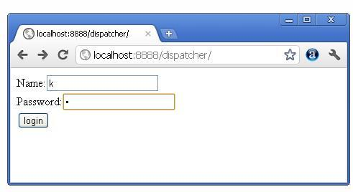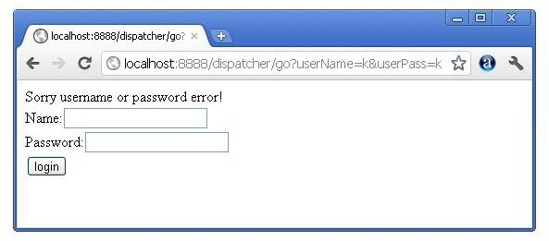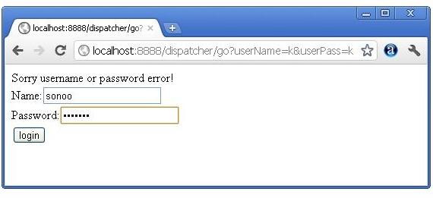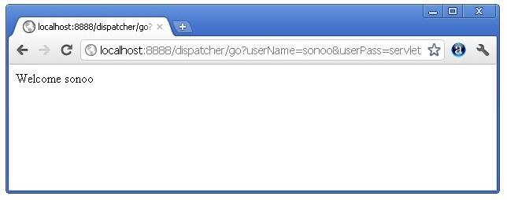

SendRedirect() method:

The sendRedirect() method of HttpServletResponse interface can be used to redirect response to another resource, it may be servlet, jsp or html file. It can accept relative URL. This method can work inside and outside the server as it uses the URL bar of the browser.

Syntax of sendRedirect() method

- public void sendRedirect(String URL)throws IOException;

Example of sendRedirect() method
In this example, we are redirecting the request to the google server. Notice that sendRedirect method works at client side, that is why we can our request to anywhere. We can send our request within and outside the server.

DemoServlet.java

- import java.io.*;
- import javax.servlet.*;
- import javax.servlet.http.*;

- public class DemoServlet extends HttpServlet{
- public void doGet(HttpServletRequest req,HttpServletResponse res)
- throws ServletException,IOException
- {
- res.setContentType("text/html");
- PrintWriter pw=res.getWriter();

- response.sendRedirect("http://www.google.com");

- pw.close();
- }}

The forward method of RequestDispatcher will forward the ServletRequest and ServletResponse that it is passed to the path that was specified in getRequestDispatcher(String path). The response will not be sent back to the client and so the client will not know about this change of resource on the server. This method is useful for communicating between server resources, (servlet to servlet). Because the request and response are forwarded to another resource all request parameters are maintained and available for use. Since the client does not know about this forward on the server, no history of it will be stored on the client, so using the back and forward buttons will not work. This method is faster than using sendRedirect as no network round trip to the server and back is required.
An example using forward:
protected void doGet(HttpServletRequest request, HttpServletResponse response)
throws ServletException, IOException {
RequestDispatcher rd = request.getRequestDispatcher("pathToResource");
rd.forward(request, response);
}
The sendRedirect(String path) method of HttpServletResponse will tell the client that it should send a request to the specified path. So the client will build a new request and submit it to the server, because a new request is being submitted all previous parameters stored in the request will be unavailable. The client's history will be updated so the forward and back buttons will work. This method is useful for redirecting to pages on other servers and domains.
An example using sendRedirect:
protected void doGet(HttpServletRequest request, HttpServletResponse response)
throws ServletException, IOException {
response.sendRedirect("pathToResource");
}

Difference between SendRedirect() and Forward() in JSP Servlet
Difference between SendRedirect and forward is one of classical interview questions asked during java web developer interview. This is not just applicable for servlet but also for JSP in which we can use forward action or call sendRedirect() method from scriptlet. Before examining difference on forward and SendRedirect let’s see what send Redirect method and forward method does.

SendRedirect ():

This method is declared in HttpServletResponse Interface.

Signature: void sendRedirect(String url)

This method is used to redirect client request to some other location for further processing ,the new location is available on different server or different context.our web container handle this and transfer the request using browser ,and this request is visible in browser as a new request. Some time this is also called as client side redirect.

Forward():
This method is declared in RequestDispatcher Interface.
Signature: forward(ServletRequest request, ServletResponse response)

This method is used to pass the request to another resource for further processing within the same server, another resource could be any servlet, jsp page any kind of file.This process is taken care by web container when we call forward method request is sent to another resource without the client being informed, which resource will handle the request it has been mention on requestDispatcher object which we can get by two ways either using ServletContext or Request. This is also called server side redirect.

RequestDispatcher rd = request.getRequestDispatcher("pathToResource");
rd.forward(request, response);

Or

RequestDispatcher rd = servletContext.getRequestDispatcher("/pathToResource");
rd.forward(request, response);

Difference between SendRedirect and Forward

Now let’s see some difference between these two method of servlet API in tabular format.

Forward() | SendRediret()
When we use forward method request is transfer to other resource within the same server for further processing. | In case of sendRedirect request is transfer to another resource to different domain or different server for futher processing.
In case of forward Web container handle all process internally and client or browser is not involved. | When you use SendRedirect container transfers the request to client or browser so url given inside the sendRedirect method is visible as a new request to the client.
When forward is called on requestdispather object we pass request and response object so our old request object is present on new resource which is going to process our request | In case of SendRedirect call old request and response object is lost because it’s treated as new request by the browser.
Visually we are not able to see the forwarded address, its is transparent | In address bar we are able to see the new redirected address it’s not transparent.
Using forward () method is faster then send redirect. | SendRedirect is slower because one extra round trip is required beasue completely new request is created and old request object is lost.Two browser request requird.
When we redirect using forward and we want to use same data in new resource we can use request.setAttribute () as we have request object available. | But in sendRedirect if we want to use we have to store the data in session or pass along with the URL.

Example of forward and SendRedirect in JSP Servlet:

Any kind of online payment when we use merchant site will redirect us to net banking site which is completely new request it process our request and again redirect to merchant site?

In Banking Application when we do login normally we use forward method. In case of online banking we are asked for username and password if it’s a correct some another servlet or resource will handle the request other wise request has been forwarded to error page.

Which one is good?

Its depends upon the scenario that which method is more useful.

If you want control is transfer to new server or context and it is treated as completely new task then we go for Send Redirect.
Normally forward should be used if the operation can be safely repeated upon a browser reload of the web page will not affect the result.

SendRedirect and forward method are still very useful while programming or working on any web application project using servlet jsp. This is still a popular interview questions so don’t forget to revise forward and sendRedirect before appearing for any job interview.

ServletConfig Interface
An object of ServletConfig is created by the web container for each servlet. This object can be used to get configuration information from web.xml file.
If the configuration information is modified from the web.xml file, we don't need to change the servlet. So it is easier to manage the web application if any specific content is modified from time to time.

Advantage of ServletConfig
The core advantage of ServletConfig is that you don't need to edit the servlet file if information is modified from the web.xml file.

Methods of ServletConfig interface
- public String getInitParameter(String name):Returns the parameter value for the specified parameter name.
- public Enumeration getInitParameterNames():Returns an enumeration of all the initialization parameter names.
- public String getServletName():Returns the name of the servlet.
- public ServletContext getServletContext():Returns an object of ServletContext.

How to get the object of ServletConfig
- getServletConfig() method of Servlet interface returns the object of ServletConfig.

Syntax of getServletConfig() method
- public ServletConfig getServletConfig();

Example of getServletConfig() method
- ServletConfig config = getServletConfig();
- //Now we can call the methods of ServletConfig interface

Syntax to provide the initialization parameter for a servlet
The init-param sub-element of servlet is used to specify the initialization parameter for a servlet.
- <web-app>
- <servlet>
- ......

- <init-param>
- <param-name>parametername</param-name>
- <param-value>parametervalue</param-value>
- </init-param>
- ......
- </servlet>
- </web-app>

Example of ServletConfig to get initialization parameter
In this example, we are getting the one initialization parameter from the web.xml file and printing this information in the servlet.
DemoServlet.java
- import java.io.*;
- import javax.servlet.*;
- import javax.servlet.http.*;

- public class DemoServlet extends HttpServlet {
- public void doGet(HttpServletRequest request, HttpServletResponse response)
- throws ServletException, IOException {

- response.setContentType("text/html");
- PrintWriter out = response.getWriter();
- ServletConfig config=getServletConfig();
- String driver=config.getInitParameter("driver");
- out.print("Driver is: "+driver);

- out.close();
- }

- }
web.xml
- <web-app>

- <servlet>
- <servlet-name>DemoServlet</servlet-name>
- <servlet-class>DemoServlet</servlet-class>

- <init-param>
- <param-name>driver</param-name>
- <param-value>sun.jdbc.odbc.JdbcOdbcDriver</param-value>
- </init-param>

- </servlet>

- <servlet-mapping>
- <servlet-name>DemoServlet</servlet-name>
- <url-pattern>/servlet1</url-pattern>
- </servlet-mapping>

- </web-app>

Example of ServletConfig to get all the initialization parameters
In this example, we are getting all the initialization parameter from the web.xml file and printing this information in the servlet.
DemoServlet.java
- import java.io.IOException;
- import java.io.PrintWriter;
- import java.util.Enumeration;

- import javax.servlet.ServletConfig;
- import javax.servlet.ServletException;
- import javax.servlet.http.HttpServlet;
- import javax.servlet.http.HttpServletRequest;
- import javax.servlet.http.HttpServletResponse;

- public class DemoServlet extends HttpServlet {
- public void doGet(HttpServletRequest request, HttpServletResponse response)
- throws ServletException, IOException {

- response.setContentType("text/html");
- PrintWriter out = response.getWriter();

- ServletConfig config=getServletConfig();
- Enumeration<String> e=config.getInitParameterNames();

- String str="";
- while(e.hasMoreElements()){
- str=e.nextElement();
- out.print("<br>Name: "+str);
- out.print(" value: "+config.getInitParameter(str));
- }

- out.close();
- }

- }
web.xml
- <web-app>

- <servlet>
- <servlet-name>DemoServlet</servlet-name>
- <servlet-class>DemoServlet</servlet-class>

- <init-param>
- <param-name>username</param-name>
- <param-value>system</param-value>
- </init-param>

- <init-param>
- <param-name>password</param-name>
- <param-value>oracle</param-value>
- </init-param>

- </servlet>

- <servlet-mapping>
- <servlet-name>DemoServlet</servlet-name>
- <url-pattern>/servlet1</url-pattern>
- </servlet-mapping>

- </web-app>

ServletContext Interface
An object of ServletContext is created by the web container at time of deploying the project. This object can be used to get configuration information from web.xml file. There is only one ServletContext object per web application.
If any information is shared to many servlet, it is better to provide it from the web.xml file using the <context-param> element.

Advantage of ServletContext
Easy to maintain if any information is shared to all the servlet, it is better to make it available for all the servlet. We provide this information from the web.xml file, so if the information is changed, we don't need to modify the servlet. Thus it removes maintenance problem.

Usage of ServletContext Interface
There can be a lot of usage of ServletContext object. Some of them are as follows:
- The object of ServletContext provides an interface between the container and servlet.
- The ServletContext object can be used to get configuration information from the web.xml file.
- The ServletContext object can be used to set, get or remove attribute from the web.xml file.
- The ServletContext object can be used to provide inter-application communication.
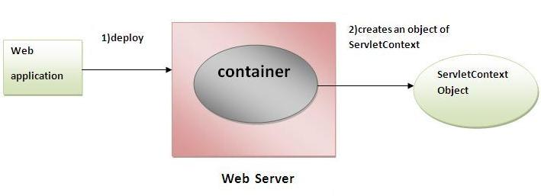

Commonly used methods of ServletContext interface
There is given some commonly used methods of ServletContext interface.

- public String getInitParameter(String name):Returns the parameter value for the specified parameter name.
- public Enumeration getInitParameterNames():Returns the names of the context's initialization parameters.
- public void setAttribute(String name,Object object):sets the given object in the application scope.
- public Object getAttribute(String name):Returns the attribute for the specified name.
- public Enumeration getInitParameterNames():Returns the names of the context's initialization parameters as an Enumeration of String objects.
- public void removeAttribute(String name):Removes the attribute with the given name from the servlet context.

How to get the object of ServletContext interface

- getServletContext() method of ServletConfig interface returns the object of ServletContext.
- getServletContext() method of GenericServlet class returns the object of ServletContext.

Syntax of getServletContext() method

public ServletContext getServletContext()

Example of getServletContext() method

//We can get the ServletContext object from ServletConfig object
ServletContext application=getServletConfig().getServletContext();

//Another convenient way to get the ServletContext object
ServletContext application=getServletContext();

Syntax to provide the initialization parameter in Context scope
The context-param element, subelement of web-app, is used to define the initialization parameter in the application scope. The param-name and param-value are the sub-elements of the context-param. The param-name element defines parameter name and and param-value defines its value.

<web-app>
......

<context-param>
<param-name>parametername</param-name>
<param-value>parametervalue</param-value>
</context-param>
......
</web-app>

Example of ServletContext to get the initialization parameter
In this example, we are getting the initialization parameter from the web.xml file and printing the value of the initialization parameter. Notice that the object of ServletContext represents the application scope. So if we change the value of the parameter from the web.xml file, all the servlet classes will get the changed value. So we don't need to modify the servlet. So it is better to have the common information for most of the servlets in the web.xml file by context-param element. Let's see the simple example:

DemoServlet.java

import java.io.*;
import javax.servlet.*;
import javax.servlet.http.*;

public class DemoServlet extends HttpServlet{
public void doGet(HttpServletRequest req,HttpServletResponse res)
throws ServletException,IOException
{
res.setContentType("text/html");
PrintWriter pw=res.getWriter();

//creating ServletContext object
ServletContext context=getServletContext();

//Getting the value of the initialization parameter and printing it
String driverName=context.getInitParameter("dname");
pw.println("driver name is="+driverName);

pw.close();

}}

web.xml

<web-app>

<servlet>
<servlet-name>sonoojaiswal</servlet-name>
<servlet-class>DemoServlet</servlet-class>
</servlet>

<context-param>
<param-name>dname</param-name>
<param-value>sun.jdbc.odbc.JdbcOdbcDriver</param-value>
</context-param>

<servlet-mapping>
<servlet-name>sonoojaiswal</servlet-name>
<url-pattern>/context</url-pattern>
</servlet-mapping>

</web-app>

Example of ServletContext to get all the initialization parameters
In this example, we are getting all the initialization parameter from the web.xml file. For getting all the parameters, we have used the getInitParameterNames() method in the servlet class.

DemoServlet.java

import java.io.*;
import javax.servlet.*;
import javax.servlet.http.*;

public class DemoServlet extends HttpServlet{
public void doGet(HttpServletRequest req,HttpServletResponse res)
throws ServletException,IOException
{
res.setContentType("text/html");
PrintWriter out=res.getWriter();

ServletContext context=getServletContext();
Enumeration<String> e=context.getInitParameterNames();

String str="";
while(e.hasMoreElements()){
str=e.nextElement();
out.print("<br> "+context.getInitParameter(str));
}
}}

web.xml
<web-app>

<servlet>
<servlet-name>sonoojaiswal</servlet-name>
<servlet-class>DemoServlet</servlet-class>
</servlet>

<context-param>
<param-name>dname</param-name>
<param-value>sun.jdbc.odbc.JdbcOdbcDriver</param-value>
</context-param>

<context-param>
<param-name>username</param-name>
<param-value>system</param-value>
</context-param>

<context-param>
<param-name>password</param-name>
<param-value>oracle</param-value>
</context-param>

<servlet-mapping>
<servlet-name>sonoojaiswal</servlet-name>
<url-pattern>/context</url-pattern>
</servlet-mapping>
</web-app>

Attribute in Servlet
An attribute in servlet is an object that can be set, get or removed from one of the following scopes:
- request scope
- session scope
- application scope
The servlet programmer can pass informations from one servlet to another using attributes. It is just like passing object from one class to another so that we can reuse the same object again and again.
Attribute specific methods of ServletRequest, HttpSession and ServletContext interface
There are following 4 attribute specific methods. They are as follows:

- public void setAttribute(String name,Object object):sets the given object in the application scope.
- public Object getAttribute(String name):Returns the attribute for the specified name.
- public Enumeration getInitParameterNames():Returns the names of the context's initialization parameters as an Enumeration of String objects.
- public void removeAttribute(String name):Removes the attribute with the given name from the servlet context.

Example of ServletContext to set and get attribute
In this example, we are setting the attribute in the application scope and getting that value from another servlet.

DemoServlet1.java

import java.io.*;
import javax.servlet.*;
import javax.servlet.http.*;

public class DemoServlet1 extends HttpServlet{
public void doGet(HttpServletRequest req,HttpServletResponse res)
{
try{

res.setContentType("text/html");
PrintWriter out=res.getWriter();

ServletContext context=getServletContext();
context.setAttribute("company","IBM");

out.println("Welcome to first servlet");
out.println("<a href='servlet2'>visit</a>");
out.close();

}catch(Exception e){out.println(e);}

}}

DemoServlet2.java

import java.io.*;
import javax.servlet.*;
import javax.servlet.http.*;

public class DemoServlet2 extends HttpServlet{
public void doGet(HttpServletRequest req,HttpServletResponse res)
{
try{

res.setContentType("text/html");
PrintWriter out=res.getWriter();

ServletContext context=getServletContext();
String n=(String)context.getAttribute("company");

out.println("Welcome to "+n);
out.close();

}catch(Exception e){out.println(e);}

}}

web.xml

<web-app>

<servlet>
<servlet-name>s1</servlet-name>
<servlet-class>DemoServlet1</servlet-class>
</servlet>

<servlet-mapping>
<servlet-name>s1</servlet-name>
<url-pattern>/servlet1</url-pattern>
</servlet-mapping>

<servlet>
<servlet-name>s2</servlet-name>
<servlet-class>DemoServlet2</servlet-class>
</servlet>

<servlet-mapping>
<servlet-name>s2</servlet-name>
<url-pattern>/servlet2</url-pattern>
</servlet-mapping>

</web-app>
Difference between ServletConfig and ServletContext
The servletconfig object refers to the single servlet whereas servletcontext object refers to the whole web application.

Session Tracking in Servlets
Session simply means a particular interval of time.
Session Tracking is a way to maintain state (data) of an user. It is also known as session management in servlet.
Http protocol is a stateless so we need to maintain state using session tracking techniques. Each time user requests to the server, server treats the request as the new request. So we need to maintain the state of an user to recognize to particular user.
HTTP is stateless that means each request is considered as the new request. It is shown in the figure given below:
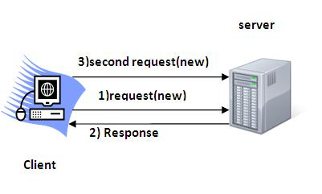

Why use Session Tracking?
To recognize the user It is used to recognize the particular user.

Session Tracking Techniques
There are four techniques used in Session tracking:
- Cookies
- Hidden Form Field
- URL Rewriting
- HttpSession

Cookies in Servlet
A cookie is a small piece of information that is persisted between the multiple client requests.
A cookie has a name, a single value, and optional attributes such as a comment, path and domain qualifiers, a maximum age, and a version number.

How Cookie works
By default, each request is considered as a new request. In cookies technique, we add cookie with response from the servlet. So cookie is stored in the cache of the browser. After that if request is sent by the user, cookie is added with request by default. Thus, we recognize the user as the old user.
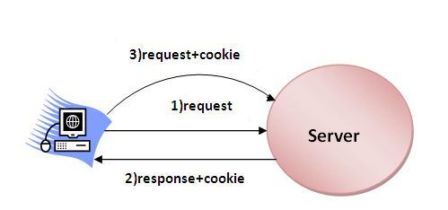

Types of Cookie
There are 2 types of cookies in servlets.
- Non-persistent cookie
- Persistent cookie

Non-persistent cookie
It is valid for single session only. It is removed each time when user closes the browser.

Persistent cookie
It is valid for multiple session . It is not removed each time when user closes the browser. It is removed only if user logout or signout.

Advantage of Cookies
- Simplest technique of maintaining the state.
- Cookies are maintained at client side.

Disadvantage of Cookies
- It will not work if cookie is disabled from the browser.
- Only textual information can be set in Cookie object.

Cookie class
javax.servlet.http.Cookie class provides the functionality of using cookies. It provides a lot of useful methods for cookies.

Constructor of Cookie class
Constructor | Description
Cookie() | constructs a cookie.
Cookie(String name, String value) | constructs a cookie with a specified name and value.

Useful Methods of Cookie class
There are given some commonly used methods of the Cookie class.
Method | Description
public void setMaxAge(int expiry) | Sets the maximum age of the cookie in seconds.
public String getName() | Returns the name of the cookie. The name cannot be changed after creation.
public String getValue() | Returns the value of the cookie.
public void setName(String name) | changes the name of the cookie.
public void setValue(String value) | changes the value of the cookie.

Other methods required for using Cookies
For adding cookie or getting the value from the cookie, we need some methods provided by other interfaces. They are:
- public void addCookie(Cookie ck):method of HttpServletResponse interface is used to add cookie in response object.
- public Cookie[] getCookies():method of HttpServletRequest interface is used to return all the cookies from the browser.
How to create Cookie?

Let's see the simple code to create cookie.

Cookie ck=new Cookie("user","sonoo jaiswal");//creating cookie object
response.addCookie(ck);//adding cookie in the response

How to delete Cookie?

Let's see the simple code to delete cookie. It is mainly used to logout or signout the user.

Cookie ck=new Cookie("user","");//deleting value of cookie
ck.setMaxAge(0);//changing the maximum age to 0 seconds
response.addCookie(ck);//adding cookie in the response

How to get Cookies?

Let's see the simple code to get all the cookies.

Cookie ck[]=request.getCookies();
for(int i=0;i<ck.length;i++){
out.print("<br>"+ck[i].getName()+" "+ck[i].getValue());//printing name and value of cookie
}

Simple example of Servlet Cookies

In this example, we are storing the name of the user in the cookie object and accessing it in another servlet. As we know well that session corresponds to the particular user. So if you access it from too many browsers with different values, you will get the different value.
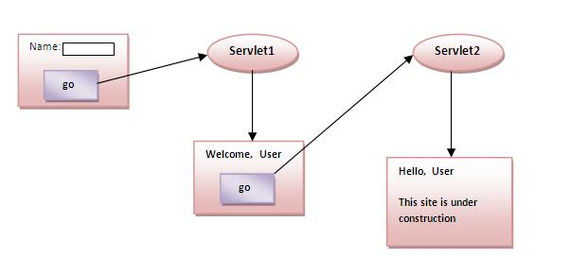

index.html
- <form action="servlet1" method="post">
- Name:<input type="text" name="userName"/><br/>
- <input type="submit" value="go"/>
- </form>

FirstServlet.java
- import java.io.*;
- import javax.servlet.*;
- import javax.servlet.http.*;

- public class FirstServlet extends HttpServlet {

- public void doPost(HttpServletRequest request, HttpServletResponse response){
- try{

- response.setContentType("text/html");
- PrintWriter out = response.getWriter();

- String n=request.getParameter("userName");
- out.print("Welcome "+n);

- Cookie ck=new Cookie("uname",n);//creating cookie object
- response.addCookie(ck);//adding cookie in the response

- //creating submit button
- out.print("<form action='servlet2'>");
- out.print("<input type='submit' value='go'>");
- out.print("</form>");

- out.close();

- }catch(Exception e){System.out.println(e);}
- }
- }

SecondServlet.java
- import java.io.*;
- import javax.servlet.*;
- import javax.servlet.http.*;

- public class SecondServlet extends HttpServlet {

- public void doPost(HttpServletRequest request, HttpServletResponse response){
- try{

- response.setContentType("text/html");
- PrintWriter out = response.getWriter();

- Cookie ck[]=request.getCookies();
- out.print("Hello "+ck[0].getValue());

- out.close();

- }catch(Exception e){System.out.println(e);}
- }

- }

web.xml
- <web-app>

- <servlet>
- <servlet-name>s1</servlet-name>
- <servlet-class>FirstServlet</servlet-class>
- </servlet>

- <servlet-mapping>
- <servlet-name>s1</servlet-name>
- <url-pattern>/servlet1</url-pattern>
- </servlet-mapping>

- <servlet>
- <servlet-name>s2</servlet-name>
- <servlet-class>SecondServlet</servlet-class>
- </servlet>

- <servlet-mapping>
- <servlet-name>s2</servlet-name>
- <url-pattern>/servlet2</url-pattern>
- </servlet-mapping>

- </web-app>

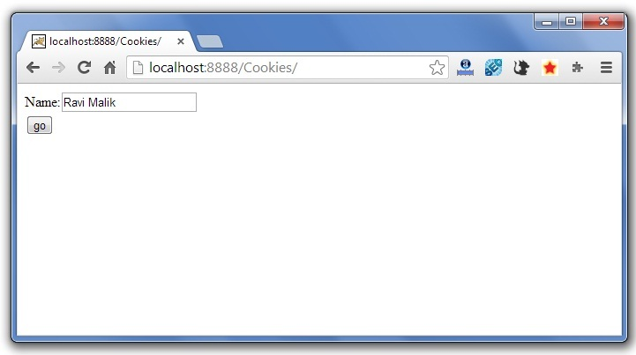

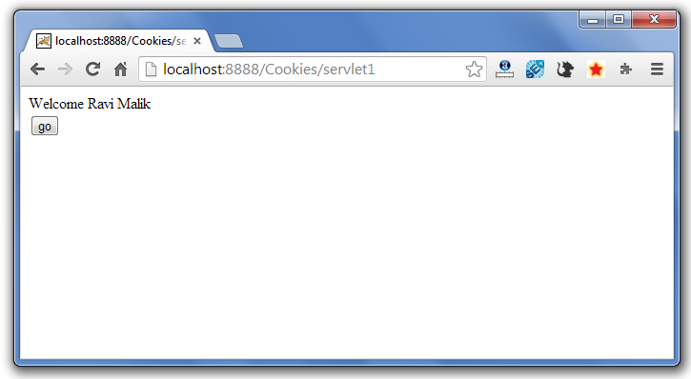
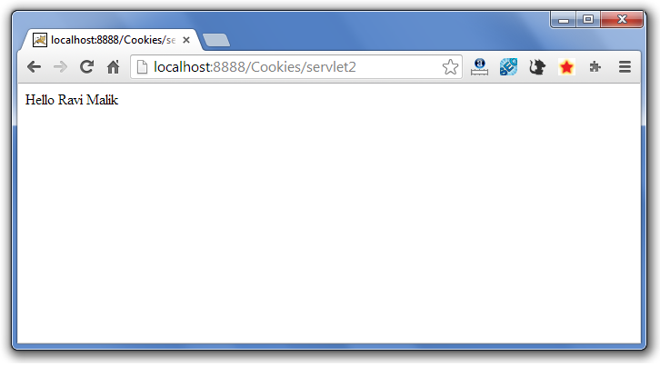

Servlet Login and Logout Example using Cookies
A cookie is a kind of information that is stored at client side.
In the previous page, we learned a lot about cookie e.g. how to create cookie, how to delete cookie, how to get cookie etc.
Here, we are going to create a login and logout example using servlet cookies.
In this example, we are creating 3 links: login, logout and profile. User can't go to profile page until he/she is logged in. If user is logged out, he need to login again to visit profile.
In this application, we have created following files.
- index.html
- link.html
- login.html
- LoginServlet.java
- LogoutServlet.java
- ProfileServlet.java
- web.xml
File: index.html
- <!DOCTYPE html>
- <html>
- <head>
- <meta charset="ISO-8859-1">
- <title>Servlet Login Example</title>
- </head>
- <body>

- <h1>Welcome to Login App by Cookie</h1>
- <a href="login.html">Login</a>|
- <a href="LogoutServlet">Logout</a>|
- <a href="ProfileServlet">Profile</a>

- </body>
- </html>

File: link.html

- <a href="login.html">Login</a> |
- <a href="LogoutServlet">Logout</a> |
- <a href="ProfileServlet">Profile</a>
- <hr>

File: login.html

- <form action="LoginServlet" method="post">
- Name:<input type="text" name="name"><br>
- Password:<input type="password" name="password"><br>
- <input type="submit" value="login">
- </form>

File: LoginServlet.java

- package com.javatpoint;

- import java.io.IOException;
- import java.io.PrintWriter;
- import javax.servlet.ServletException;
- import javax.servlet.http.Cookie;
- import javax.servlet.http.HttpServlet;
- import javax.servlet.http.HttpServletRequest;
- import javax.servlet.http.HttpServletResponse;
- public class LoginServlet extends HttpServlet {
- protected void doPost(HttpServletRequest request, HttpServletResponse response)
- throws ServletException, IOException {
- response.setContentType("text/html");
- PrintWriter out=response.getWriter();

- request.getRequestDispatcher("link.html").include(request, response);

- String name=request.getParameter("name");
- String password=request.getParameter("password");

- if(password.equals("admin123")){
- out.print("You are successfully logged in!");
- out.print("<br>Welcome, "+name);

- Cookie ck=new Cookie("name",name);
- response.addCookie(ck);
- }else{
- out.print("sorry, username or password error!");
- request.getRequestDispatcher("login.html").include(request, response);
- }

- out.close();
- }

- }

File: LogoutServlet.java

- package com.javatpoint;

- import java.io.IOException;
- import java.io.PrintWriter;
- import javax.servlet.ServletException;
- import javax.servlet.http.Cookie;
- import javax.servlet.http.HttpServlet;
- import javax.servlet.http.HttpServletRequest;
- import javax.servlet.http.HttpServletResponse;
- public class LogoutServlet extends HttpServlet {
- protected void doGet(HttpServletRequest request, HttpServletResponse response)
- throws ServletException, IOException {
- response.setContentType("text/html");
- PrintWriter out=response.getWriter();

- request.getRequestDispatcher("link.html").include(request, response);

- Cookie ck=new Cookie("name","");
- ck.setMaxAge(0);
- response.addCookie(ck);

- out.print("you are successfully logged out!");
- }
- }

File: ProfileServlet.java

- package com.javatpoint;

- import java.io.IOException;
- import java.io.PrintWriter;
- import javax.servlet.ServletException;
- import javax.servlet.http.Cookie;
- import javax.servlet.http.HttpServlet;
- import javax.servlet.http.HttpServletRequest;
- import javax.servlet.http.HttpServletResponse;
- public class ProfileServlet extends HttpServlet {
- protected void doGet(HttpServletRequest request, HttpServletResponse response)
- throws ServletException, IOException {
- response.setContentType("text/html");
- PrintWriter out=response.getWriter();

- request.getRequestDispatcher("link.html").include(request, response);

- Cookie ck[]=request.getCookies();
- if(ck!=null){
- String name=ck[0].getValue();
- if(!name.equals("")||name!=null){
- out.print("<b>Welcome to Profile</b>");
- out.print("<br>Welcome, "+name);
- }
- }else{
- out.print("Please login first");
- request.getRequestDispatcher("login.html").include(request, response);
- }
- out.close();
- }
- }

File: web.xml

- <?xml version="1.0" encoding="UTF-8"?>
- <web-app xmlns:xsi="http://www.w3.org/2001/XMLSchema-instance"
- xmlns="http://java.sun.com/xml/ns/javaee" xsi:schemaLocation="http://java.sun.com/xml/ns/javaee
- http://java.sun.com/xml/ns/javaee/web-app_2_5.xsd" id="WebApp_ID" version="2.5">

- <servlet>
- <description></description>
- <display-name>LoginServlet</display-name>
- <servlet-name>LoginServlet</servlet-name>
- <servlet-class>com.javatpoint.LoginServlet</servlet-class>
- </servlet>
- <servlet-mapping>
- <servlet-name>LoginServlet</servlet-name>
- <url-pattern>/LoginServlet</url-pattern>
- </servlet-mapping>
- <servlet>
- <description></description>
- <display-name>ProfileServlet</display-name>
- <servlet-name>ProfileServlet</servlet-name>
- <servlet-class>com.javatpoint.ProfileServlet</servlet-class>
- </servlet>
- <servlet-mapping>
- <servlet-name>ProfileServlet</servlet-name>
- <url-pattern>/ProfileServlet</url-pattern>
- </servlet-mapping>
- <servlet>
- <description></description>
- <display-name>LogoutServlet</display-name>
- <servlet-name>LogoutServlet</servlet-name>
- <servlet-class>com.javatpoint.LogoutServlet</servlet-class>
- </servlet>
- <servlet-mapping>
- <servlet-name>LogoutServlet</servlet-name>
- <url-pattern>/LogoutServlet</url-pattern>
- </servlet-mapping>
- </web-app>

Output
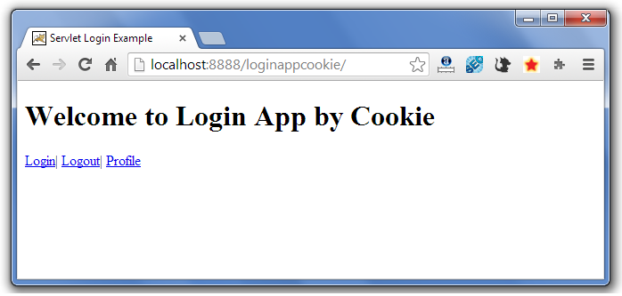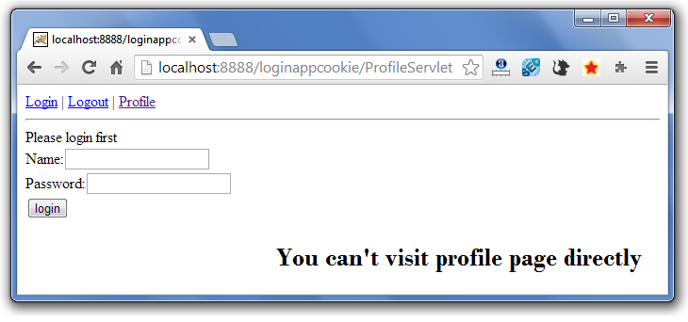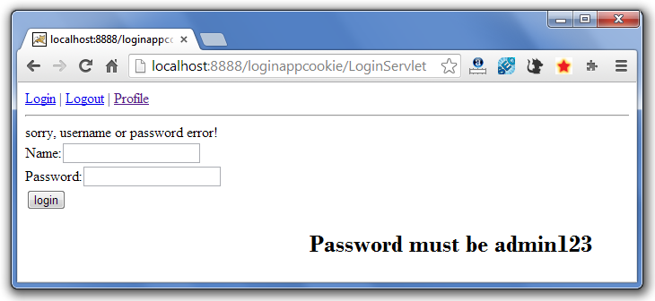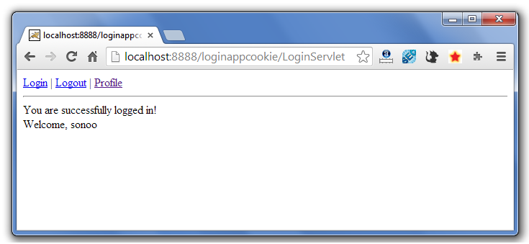
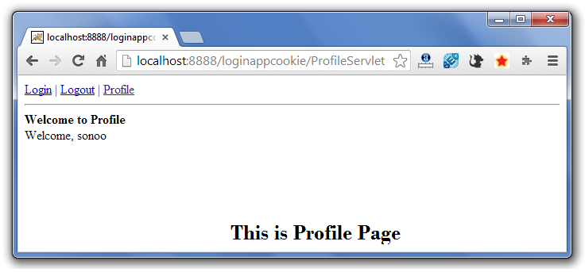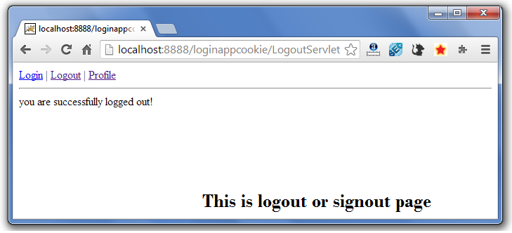
If again you click on the profile link, you need to login first.

2) Hidden Form Field
In case of Hidden Form Field a hidden (invisible) textfield is used for maintaining the state of an user.
In such case, we store the information in the hidden field and get it from another servlet. This approach is better if we have to submit form in all the pages and we don't want to depend on the browser.
Let's see the code to store value in hidden field.
Let's see the code to store value in hidden field.
- <input type="hidden" name="uname" value="Vimal Jaiswal">
Here, uname is the hidden field name and Vimal Jaiswal is the hidden field value.

Real application of hidden form field
It is widely used in comment form of a website. In such case, we store page id or page name in the hidden field so that each page can be uniquely identified.

Advantage of Hidden Form Field
- It will always work whether cookie is disabled or not.

Disadvantage of Hidden Form Field:
- It is maintained at server side.
- Extra form submission is required on each pages.
- Only textual information can be used.

Example of using Hidden Form Field
In this example, we are storing the name of the user in a hidden textfield and getting that value from another servlet.
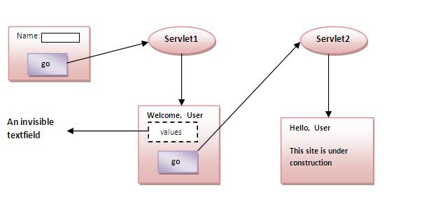

index.html
- <form action="servlet1">
- Name:<input type="text" name="userName"/><br/>
- <input type="submit" value="go"/>
- </form>

FirstServlet.java
- import java.io.*;
- import javax.servlet.*;
- import javax.servlet.http.*;

- public class FirstServlet extends HttpServlet {
- public void doGet(HttpServletRequest request, HttpServletResponse response){
- try{

- response.setContentType("text/html");
- PrintWriter out = response.getWriter();

- String n=request.getParameter("userName");
- out.print("Welcome "+n);

- //creating form that have invisible textfield
- out.print("<form action='servlet2'>");
- out.print("<input type='hidden' name='uname' value='"+n+"'>");
- out.print("<input type='submit' value='go'>");
- out.print("</form>");
- out.close();

- }catch(Exception e){System.out.println(e);}
- }

- }

SecondServlet.java
- import java.io.*;
- import javax.servlet.*;
- import javax.servlet.http.*;
- public class SecondServlet extends HttpServlet {
- public void doGet(HttpServletRequest request, HttpServletResponse response)
- try{
- response.setContentType("text/html");
- PrintWriter out = response.getWriter();

- //Getting the value from the hidden field
- String n=request.getParameter("uname");
- out.print("Hello "+n);

- out.close();
- }catch(Exception e){System.out.println(e);}
- }
- }

web.xml
- <web-app>

- <servlet>
- <servlet-name>s1</servlet-name>
- <servlet-class>FirstServlet</servlet-class>
- </servlet>

- <servlet-mapping>
- <servlet-name>s1</servlet-name>
- <url-pattern>/servlet1</url-pattern>
- </servlet-mapping>

- <servlet>
- <servlet-name>s2</servlet-name>
- <servlet-class>SecondServlet</servlet-class>
- </servlet>

- <servlet-mapping>
- <servlet-name>s2</servlet-name>
- <url-pattern>/servlet2</url-pattern>
- </servlet-mapping>

- </web-app>

3)URL Rewriting
In URL rewriting, we append a token or identifier to the URL of the next Servlet or the next resource. We can send parameter name/value pairs using the following format:
url?name1=value1&name2=value2&??
A name and a value is separated using an equal = sign, a parameter name/value pair is separated from another parameter using the ampersand(&). When the user clicks the hyperlink, the parameter name/value pairs will be passed to the server. From a Servlet, we can use getParameter() method to obtain a parameter value.
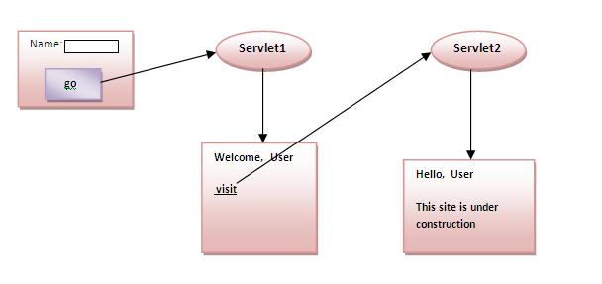

Advantage of URL Rewriting
- It will always work whether cookie is disabled or not (browser independent).
- Extra form submission is not required on each pages.

Disadvantage of URL Rewriting
- It will work only with links.
- It can send Only textual information.

Example of using URL Rewriting
In this example, we are maintaning the state of the user using link. For this purpose, we are appending the name of the user in the query string and getting the value from the query string in another page.

index.html
- <form action="servlet1">
- Name:<input type="text" name="userName"/><br/>
- <input type="submit" value="go"/>
- </form>

FirstServlet.java
- import java.io.*;
- import javax.servlet.*;
- import javax.servlet.http.*;

- public class FirstServlet extends HttpServlet {

- public void doGet(HttpServletRequest request, HttpServletResponse response){
- try{

- response.setContentType("text/html");
- PrintWriter out = response.getWriter();

- String n=request.getParameter("userName");
- out.print("Welcome "+n);

- //appending the username in the query string
- out.print("<a href='servlet2?uname="+n+"'>visit</a>");

- out.close();

- }catch(Exception e){System.out.println(e);}
- }

- }

SecondServlet.java
- import java.io.*;
- import javax.servlet.*;
- import javax.servlet.http.*;

- public class SecondServlet extends HttpServlet {

- public void doGet(HttpServletRequest request, HttpServletResponse response)
- try{

- response.setContentType("text/html");
- PrintWriter out = response.getWriter();

- //getting value from the query string
- String n=request.getParameter("uname");
- out.print("Hello "+n);

- out.close();

- }catch(Exception e){System.out.println(e);}
- }

- }

web.xml
- <web-app>

- <servlet>
- <servlet-name>s1</servlet-name>
- <servlet-class>FirstServlet</servlet-class>
- </servlet>

- <servlet-mapping>
- <servlet-name>s1</servlet-name>
- <url-pattern>/servlet1</url-pattern>
- </servlet-mapping>

- <servlet>
- <servlet-name>s2</servlet-name>
- <servlet-class>SecondServlet</servlet-class>
- </servlet>

- <servlet-mapping>
- <servlet-name>s2</servlet-name>
- <url-pattern>/servlet2</url-pattern>
- </servlet-mapping>

- </web-app>

4) HttpSession interface
In such case, container creates a session id for each user. The container uses this id to identify the particular user. An object of HttpSession can be used to perform two tasks:
- bind objects
- view and manipulate information about a session, such as the session identifier, creation time, and last accessed time.
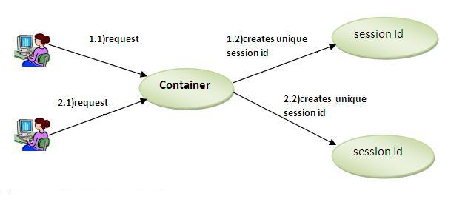

How to get the HttpSession object ?
The HttpServletRequest interface provides two methods to get the object of HttpSession:
- public HttpSession getSession():Returns the current session associated with this request, or if the request does not have a session, creates one.
- public HttpSession getSession(boolean create):Returns the current HttpSession associated with this request or, if there is no current session and create is true, returns a new session.

Commonly used methods of HttpSession interface
- public String getId():Returns a string containing the unique identifier value.
- public long getCreationTime():Returns the time when this session was created, measured in milliseconds since midnight January 1, 1970 GMT.
- public long getLastAccessedTime():Returns the last time the client sent a request associated with this session, as the number of milliseconds since midnight January 1, 1970 GMT.
- public void invalidate():Invalidates this session then unbinds any objects bound to it.

Example of using HttpSession
In this example, we are setting the attribute in the session scope in one servlet and getting that value from the session scope in another servlet. To set the attribute in the session scope, we have used the setAttribute() method of HttpSession interface and to get the attribute, we have used the getAttribute method.

index.html
- <form action="servlet1">
- Name:<input type="text" name="userName"/><br/>
- <input type="submit" value="go"/>
- </form>

FirstServlet.java
- import java.io.*;
- import javax.servlet.*;
- import javax.servlet.http.*;

- public class FirstServlet extends HttpServlet {

- public void doGet(HttpServletRequest request, HttpServletResponse response){
- try{

- response.setContentType("text/html");
- PrintWriter out = response.getWriter();

- String n=request.getParameter("userName");
- out.print("Welcome "+n);

- HttpSession session=request.getSession();
- session.setAttribute("uname",n);

- out.print("<a href='servlet2'>visit</a>");

- out.close();

- }catch(Exception e){System.out.println(e);}
- }

- }

SecondServlet.java
- import java.io.*;
- import javax.servlet.*;
- import javax.servlet.http.*;

- public class SecondServlet extends HttpServlet {

- public void doGet(HttpServletRequest request, HttpServletResponse response)
- try{

- response.setContentType("text/html");
- PrintWriter out = response.getWriter();

- HttpSession session=request.getSession(false);
- String n=(String)session.getAttribute("uname");
- out.print("Hello "+n);

- out.close();

- }catch(Exception e){System.out.println(e);}
- }

- }

web.xml
- <web-app>

- <servlet>
- <servlet-name>s1</servlet-name>
- <servlet-class>FirstServlet</servlet-class>
- </servlet>

- <servlet-mapping>
- <servlet-name>s1</servlet-name>
- <url-pattern>/servlet1</url-pattern>
- </servlet-mapping>

- <servlet>
- <servlet-name>s2</servlet-name>
- <servlet-class>SecondServlet</servlet-class>
- </servlet>

- <servlet-mapping>
- <servlet-name>s2</servlet-name>
- <url-pattern>/servlet2</url-pattern>
- </servlet-mapping>

- </web-app>

Servlet HttpSession Login and Logout Example
We can bind the objects on HttpSession instance and get the objects by using setAttribute and getAttribute methods.
In the previous page, we have learnt about what is HttpSession, How to store and get data from session object etc.
Here, we are going to create a real world login and logout application without using database code. We are assuming that password is admin123.
In this example, we are creating 3 links: login, logout and profile. User can't go to profile page until he/she is logged in. If user is logged out, he need to login again to visit profile.
In this application, we have created following files.
- index.html
- link.html
- login.html
- LoginServlet.java
- LogoutServlet.java
- ProfileServlet.java
- web.xml
File: index.html
- <!DOCTYPE html>
- <html>
- <head>
- <meta charset="ISO-8859-1">
- <title>Servlet Login Example</title>
- </head>
- <body>

- <h1>Login App using HttpSession</h1>
- <a href="login.html">Login</a>|
- <a href="LogoutServlet">Logout</a>|
- <a href="ProfileServlet">Profile</a>

- </body>
- </html>

File: link.html

- <a href="login.html">Login</a> |
- <a href="LogoutServlet">Logout</a> |
- <a href="ProfileServlet">Profile</a>
- <hr>

File: login.html

- <form action="LoginServlet" method="post">
- Name:<input type="text" name="name"><br>
- Password:<input type="password" name="password"><br>
- <input type="submit" value="login">
- </form>

File: LoginServlet.java

- import java.io.IOException;
- import java.io.PrintWriter;

- import javax.servlet.ServletException;
- import javax.servlet.http.HttpServlet;
- import javax.servlet.http.HttpServletRequest;
- import javax.servlet.http.HttpServletResponse;
- import javax.servlet.http.HttpSession;
- public class LoginServlet extends HttpServlet {
- protected void doPost(HttpServletRequest request, HttpServletResponse response)
- throws ServletException, IOException {
- response.setContentType("text/html");
- PrintWriter out=response.getWriter();
- request.getRequestDispatcher("link.html").include(request, response);

- String name=request.getParameter("name");
- String password=request.getParameter("password");

- if(password.equals("admin123")){
- out.print("Welcome, "+name);
- HttpSession session=request.getSession();
- session.setAttribute("name",name);
- }
- else{
- out.print("Sorry, username or password error!");
- request.getRequestDispatcher("login.html").include(request, response);
- }
- out.close();
- }
- }

File: LogoutServlet.java

- import java.io.IOException;
- import java.io.PrintWriter;

- import javax.servlet.ServletException;
- import javax.servlet.http.HttpServlet;
- import javax.servlet.http.HttpServletRequest;
- import javax.servlet.http.HttpServletResponse;
- import javax.servlet.http.HttpSession;
- public class LogoutServlet extends HttpServlet {
- protected void doGet(HttpServletRequest request, HttpServletResponse response)
- throws ServletException, IOException {
- response.setContentType("text/html");
- PrintWriter out=response.getWriter();

- request.getRequestDispatcher("link.html").include(request, response);

- HttpSession session=request.getSession();
- session.invalidate();

- out.print("You are successfully logged out!");

- out.close();
- }
- }

File: ProfileServlet.java

- import java.io.IOException;
- import java.io.PrintWriter;
- import javax.servlet.ServletException;
- import javax.servlet.http.HttpServlet;
- import javax.servlet.http.HttpServletRequest;
- import javax.servlet.http.HttpServletResponse;
- import javax.servlet.http.HttpSession;
- public class ProfileServlet extends HttpServlet {
- protected void doGet(HttpServletRequest request, HttpServletResponse response)
- throws ServletException, IOException {
- response.setContentType("text/html");
- PrintWriter out=response.getWriter();
- request.getRequestDispatcher("link.html").include(request, response);

- HttpSession session=request.getSession(false);
- if(session!=null){
- String name=(String)session.getAttribute("name");

- out.print("Hello, "+name+" Welcome to Profile");
- }
- else{
- out.print("Please login first");
- request.getRequestDispatcher("login.html").include(request, response);
- }
- out.close();
- }
- }

File: web.xml

- <?xml version="1.0" encoding="UTF-8"?>
- <web-app xmlns:xsi="http://www.w3.org/2001/XMLSchema-instance"
- xmlns="http://java.sun.com/xml/ns/javaee" xsi:schemaLocation="http://java.sun.com/xml/ns/javaee
- http://java.sun.com/xml/ns/javaee/web-app_2_5.xsd" id="WebApp_ID" version="2.5">

- <servlet>
- <description></description>
- <display-name>LoginServlet</display-name>
- <servlet-name>LoginServlet</servlet-name>
- <servlet-class>LoginServlet</servlet-class>
- </servlet>
- <servlet-mapping>
- <servlet-name>LoginServlet</servlet-name>
- <url-pattern>/LoginServlet</url-pattern>
- </servlet-mapping>
- <servlet>
- <description></description>
- <display-name>ProfileServlet</display-name>
- <servlet-name>ProfileServlet</servlet-name>
- <servlet-class>ProfileServlet</servlet-class>
- </servlet>
- <servlet-mapping>
- <servlet-name>ProfileServlet</servlet-name>
- <url-pattern>/ProfileServlet</url-pattern>
- </servlet-mapping>
- <servlet>
- <description></description>
- <display-name>LogoutServlet</display-name>
- <servlet-name>LogoutServlet</servlet-name>
- <servlet-class>LogoutServlet</servlet-class>
- </servlet>
- <servlet-mapping>
- <servlet-name>LogoutServlet</servlet-name>
- <url-pattern>/LogoutServlet</url-pattern>
- </servlet-mapping>
- </web-app>

Output
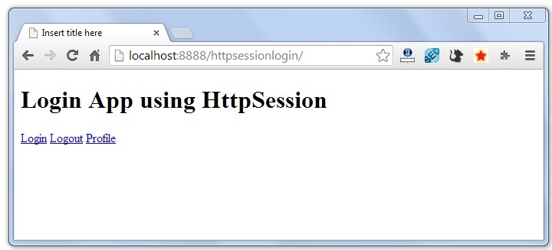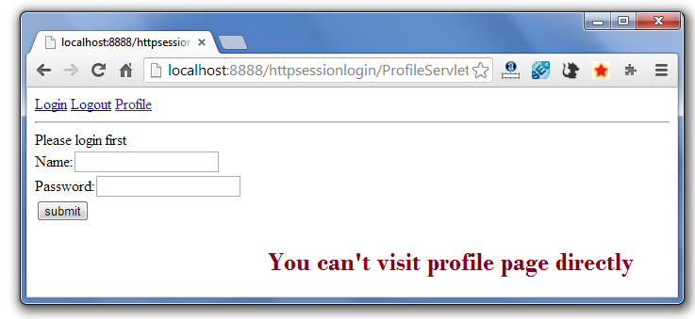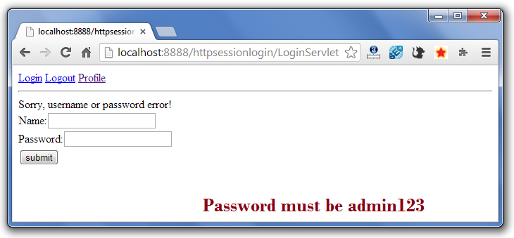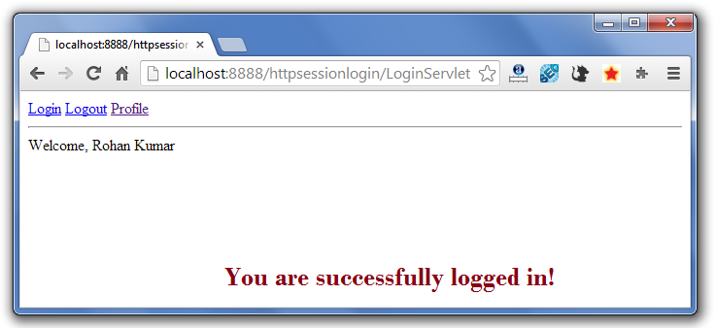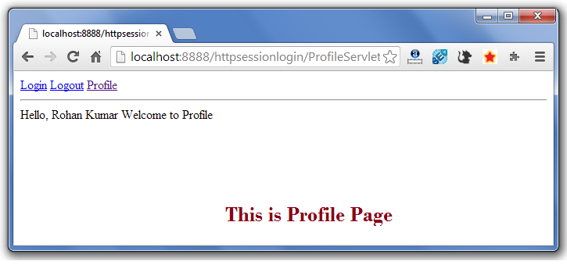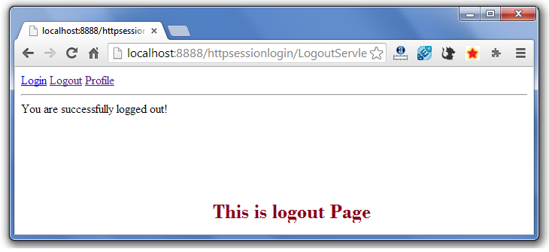
If again you click on the profile link, you need to login first.

Servlet Filter:

A filter is an object that performs filtering tasks on either the request to a resource (a servlet or static content), or on the response from a resource, or both.
Filters perform filtering in the doFilter method. Every Filter has access to a FilterConfig object from which it can obtain its initialization parameters, a reference to the ServletContext which it can use, for example, to load resources needed for filtering tasks.
Filters are configured in the deployment descriptor of a web application
Examples that have been identified for this design are
1) Authentication Filters
2) Logging and Auditing Filters
3) Image conversion Filters
4) Data compression Filters
5) Encryption Filters
6) Tokenizing Filters
7) Filters that trigger resource access events
8) XSL/T filters
9) Mime-type chain Filter
Since: Servlet 2.3

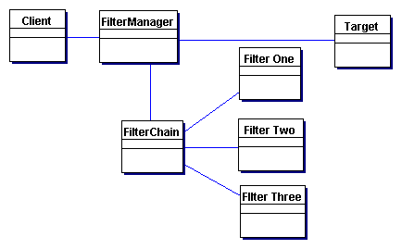

FilterManager
The FilterManager manages filter processing. It creates the FilterChain with the appropriate filters, in the correct order, and initiates processing.

FilterChain
The FilterChain is an ordered collection of independent filters.

FilterOne, FilterTwo, FilterThree
These are the individual filters that are mapped to a target. The FilterChain coordinates their processing.

Target
The Target is the resource requested by the client.

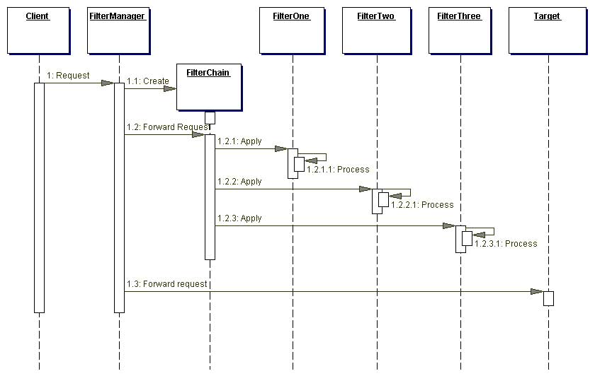

Fliter.java interface:

package javax.servlet;
import java.io.IOException;
public interface Filter {
/ * Called by the web container to indicate to a filter that it is being placed into service. The servlet container calls the init method exactly once after instantiating the filter. The init method must complete successfully before the filter is asked to do any filtering work.
The web container cannot place the filter into service if the init method either
1.Throws a ServletException
2.Does not return within a time period defined by the web container */

public void init(FilterConfig filterConfig) throws ServletException;
/* The doFilter method of the Filter is called by the container each time a request/response pair is passed through the chain due to a client request for a resource at the end of the chain. The FilterChain passed in to this method allows the Filter to pass on the request and response to the next entity in the chain.
A typical implementation of this method would follow the following pattern:-
1. Examine the request
2. Optionally wrap the request object with a custom implementation to filter content or headers for input filtering
3. Optionally wrap the response object with a custom implementation to filter content or headers for output filtering
4. a) Either invoke the next entity in the chain using the FilterChain object (chain.doFilter()),
4. b) or not pass on the request/response pair to the next entity in the filter chain to block the request processing
5. Directly set headers on the response after invocation of the next entity in the filter chain. */
public void doFilter ( ServletRequest request, ServletResponse response, FilterChain chain ) throws IOException, ServletException;
/* Called by the web container to indicate to a filter that it is being taken out of service. This method is only called once all threads within the filter's doFilter method have exited or after a timeout period has passed. After the web container calls this method, it will not call the doFilter method again on this instance of the filter.
This method gives the filter an opportunity to clean up any resources that are being held (for example, memory, file handles, threads) and make sure that any persistent state is synchronized with the filter's current state in memory. */

public void destroy();
}

A FilterChain is an object provided by the servlet container to the developer giving a view into the invocation chain of a filtered request for a resource. Filters use the FilterChain to invoke the next filter in the chain, or if the calling filter is the last filter in the chain, to invoke the rosource at the end of the chain.

Filterchain.java:

package javax.servlet;
import java.io.IOException;
public interface FilterChain {
/*Causes the next filter in the chain to be invoked, or if the calling filter is the last filter in the chain, causes the resource at the end of the chain to be invoked.
Parameters:
request the request to pass along the chain.
response the response to pass along the chain. */
public void doFilter(ServletRequest request, ServletResponse response) throws IOException, ServletException;
}
A filter is an object that is invoked at the preprocessing and postprocessing of a request.
It is mainly used to perform filtering tasks such as conversion, logging, compression, encryption and decryption, input validation etc.
The servlet filter is pluggable, i.e. its entry is defined in the web.xml file, if we remove the entry of filter from the web.xml file, filter will be removed automatically and we don't need to change the servlet.
So maintenance cost will be less.
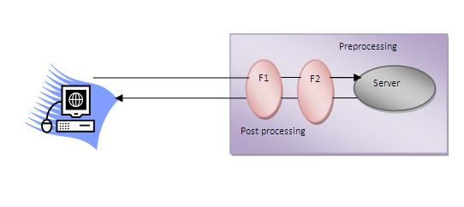
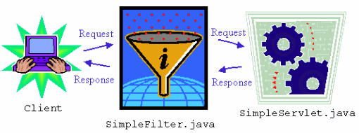

Note: Unlike Servlet, One filter doesn't have dependency on another filter.

Usage of Filter
- recording all incoming requests
- logs the IP addresses of the computers from which the requests originate
- conversion
- data compression
- encryption and decryption
- input validation etc.
A filter is an object that can transform a request or modify a response. Filters are not servlets; they don't actually create a response. They are preprocessors of the request before it reaches a servlet, and/or postprocessors of the response leaving a servlet. As you'll see later in the examples, a filter can:
- Intercept a servlet's invocation before the servlet is called
- Examine a request before a servlet is called
- Modify the request headers and request data by providing a customized version of the request object that wraps the real request
- Modify the response headers and response data by providing a customized version of the response object that wraps the real response
- Intercept a servlet's invocation after the servlet is called
You can configure a filter to act on a servlet or group of servlets. Zero or more filters can filter one or more servlets. A filter implements javax.servlet.Filter and defines its three methods:
- void init(FilterConfig config) throws ServletException: Called before the filter goes into service, and sets the filter's configuration object
- void destroy(): Called after the filter has been taken out of service
- void doFilter(ServletRequest req, ServletResponse res, FilterChain chain) throws IOException, ServletException: Performs the actual filtering work

Advantage of Filter
- Filter is pluggable.
- One filter don't have dependency onto another resource.
- Less Maintenance

Filter API
Like servlet filter have its own API. The javax.servlet package contains the three interfaces of Filter API.
- Filter
- FilterChain
- FilterConfig

1) Filter interface
For creating any filter, you must implement the Filter interface. Filter interface provides the life cycle methods for a filter.
Method | Description
public void init(FilterConfig config) | init() method is invoked only once. It is used to initialize the filter.
public void doFilter(HttpServletRequest request,HttpServletResponse response, FilterChain chain) | doFilter() method is invoked every time when user request to any resource, to which the filter is mapped.It is used to perform filtering tasks.
public void destroy() | This is invoked only once when filter is taken out of the service.

2) FilterChain interface
The object of FilterChain is responsible to invoke the next filter or resource in the chain.This object is passed in the doFilter method of Filter interface.The FilterChain interface contains only one method:
- public void doFilter(HttpServletRequest request, HttpServletResponse response): it passes the control to the next filter or resource.

How to define Filter
We can define filter same as servlet. Let's see the elements of filter and filter-mapping.
- <web-app>

- <filter>
- <filter-name>...</filter-name>
- <filter-class>...</filter-class>
- </filter>

- <filter-mapping>
- <filter-name>...</filter-name>
- <url-pattern>...</url-pattern>
- </filter-mapping>

- </web-app>
For mapping filter we can use, either url-pattern or servlet-name. The url-pattern elements has an advantage over servlet-name element i.e. it can be applied on servlet, JSP or HTML.
Servlet Filters are Java classes that can be used in Servlet Programming for the following purposes:
- To intercept requests from a client before they access a resource at back end.
- To manipulate responses from server before they are sent back to the client.
Filters are deployed in the deployment descriptor file web.xml and then map to either servlet names or URL patterns in your application's deployment descriptor.
When the web container starts up your web application, it creates an instance of each filter that you have declared in the deployment descriptor. The filters execute in the order that they are declared in the deployment descriptor.
Servlet Filter Example that would print the clients IP address and current date time:

// Import required java libraries
import java.io.*;
import javax.servlet.*;
import javax.servlet.http.*;
import java.util.*;

// Implements Filter class
public class LogFilter implements Filter {
public void init(FilterConfig config)
throws ServletException{
// Get init parameter
String testParam = config.getInitParameter("test-param");

//Print the init parameter
System.out.println("Test Param: " + testParam);
}
public void doFilter(ServletRequest request,
ServletResponse response,
FilterChain chain)
throws java.io.IOException, ServletException {

// Get the IP address of client machine.
String ipAddress = request.getRemoteAddr();

// Log the IP address and current timestamp.
System.out.println("IP "+ ipAddress + ", Time "
+ new Date().toString());

// Pass request back down the filter chain
chain.doFilter(request,response);
}
public void destroy( ){
/* Called before the Filter instance is removed
from service by the web container*/
}
}
Compile LogFilter.java in usual way and put your class file in <Tomcat-installation-directory>/webapps/ROOT/WEB-INF/classes.

Servlet Filter Mapping in Web.xml:
Filters are defined and then mapped to a URL or Servlet, in much the same way as Servlet is defined and then mapped to a URL pattern. Create the following entry for filter tag in the deployment descriptor file web.xml
<filter>
<filter-name>LogFilter</filter-name>
<filter-class>LogFilter</filter-class>
<init-param>
<param-name>test-param</param-name>
<param-value>Initialization Paramter</param-value>
</init-param>
</filter>
<filter-mapping>
<filter-name>LogFilter</filter-name>
<url-pattern>/*</url-pattern>
</filter-mapping>
The above filter would apply to all the servlets because we specified /* in our configuration. You can specicy a particular servlet path if you want to apply filter on few servlets only.
Now try to call any servlet in usual way and you would see generated log in your web server log. You can use Log4J logger to log above log in a separate file.

Using Multiple Filters:
Your web application may define several different filters with a specific purpose. Consider, you define two filters AuthenFilter and LogFilter. Rest of the process would remain as explained above except you need to create a different mapping as mentioned below:
<filter>
<filter-name>LogFilter</filter-name>
<filter-class>LogFilter</filter-class>
<init-param>
<param-name>test-param</param-name>
<param-value>Initialization Paramter</param-value>
</init-param>
</filter>

<filter>
<filter-name>AuthenFilter</filter-name>
<filter-class>AuthenFilter</filter-class>
<init-param>
<param-name>test-param</param-name>
<param-value>Initialization Paramter</param-value>
</init-param>
</filter>

<filter-mapping>
<filter-name>LogFilter</filter-name>
<url-pattern>/*</url-pattern>
</filter-mapping>

<filter-mapping>
<filter-name>AuthenFilter</filter-name>
<url-pattern>/*</url-pattern>
</filter-mapping>

Filters Application Order:
The order of filter-mapping elements in web.xml determines the order in which the web container applies the filter to the servlet. To reverse the order of the filter, you just need to reverse the filter-mapping elements in the web.xml file.
For example, above example would apply LogFilter first and then it would apply AuthenFilter to any servlet but the following example would reverse the order:
<filter-mapping>
<filter-name>AuthenFilter</filter-name>
<url-pattern>/*</url-pattern>
</filter-mapping>

<filter-mapping>
<filter-name>LogFilter</filter-name>
<url-pattern>/*</url-pattern>
</filter-mapping>

Simple Example of Filter
In this example, we are simply displaying information that filter is invoked automatically after the post processing of the request.

index.html
- <a href="servlet1">click here</a>

MyFilter.java
- import java.io.IOException;
- import java.io.PrintWriter;

- import javax.servlet.*;

- public class MyFilter implements Filter{

- public void init(FilterConfig arg0) throws ServletException {}

- public void doFilter(ServletRequest req, ServletResponse resp,
- FilterChain chain) throws IOException, ServletException {

- PrintWriter out=resp.getWriter();
- out.print("filter is invoked before");

- chain.doFilter(req, resp);//sends request to next resource

- out.print("filter is invoked after");
- }
- public void destroy() {}
- }

HelloServlet.java
- import java.io.IOException;
- import java.io.PrintWriter;

- import javax.servlet.ServletException;
- import javax.servlet.http.*;

- public class HelloServlet extends HttpServlet {
- public void doGet(HttpServletRequest request, HttpServletResponse response)
- throws ServletException, IOException {

- response.setContentType("text/html");
- PrintWriter out = response.getWriter();

- out.print("<br>welcome to servlet<br>");

- }

- }
web.xml
For defining the filter, filter element of web-app must be defined just like servlet.

- <web-app>

- <servlet>
- <servlet-name>s1</servlet-name>
- <servlet-class>HelloServlet</servlet-class>
- </servlet>

- <servlet-mapping>
- <servlet-name>s1</servlet-name>
- <url-pattern>/servlet1</url-pattern>
- </servlet-mapping>

- <filter>
- <filter-name>f1</filter-name>
- <filter-class>MyFilter</filter-class>
- </filter>

- <filter-mapping>
- <filter-name>f1</filter-name>
- <url-pattern>/servlet1</url-pattern>
- </filter-mapping>

- </web-app>

Authentication Filter
We can perform authentication in filter. Here, we are going to check to password given by the user in filter class, if given password is admin, it will forward the request to the WelcomeAdmin servlet otherwise it will display error message.

Example of authenticating user using filter
Let's see the simple example of authenticating user using filter.
Here, we have created 4 files:
- index.html
- MyFilter.java
- AdminServlet.java
- web.xml
index.html

- <form action="servlet1">
- Name:<input type="text" name="name"/><br/>
- Password:<input type="password" name="password"/><br/>

- <input type="submit" value="login">

- </form>
MyFilter.java

- import java.io.IOException;
- import java.io.PrintWriter;
- import javax.servlet.*;

- public class MyFilter implements Filter{

- public void init(FilterConfig arg0) throws ServletException {}

- public void doFilter(ServletRequest req, ServletResponse resp,
- FilterChain chain) throws IOException, ServletException {

- PrintWriter out=resp.getWriter();

- String password=req.getParameter("password");
- if(password.equals("admin")){
- chain.doFilter(req, resp);//sends request to next resource
- }
- else{
- out.print("username or password error!");
- RequestDispatcher rd=req.getRequestDispatcher("index.html");
- rd.include(req, resp);
- }

- }
- public void destroy() {}

- }
AdminServlet.java

- import java.io.IOException;
- import java.io.PrintWriter;

- import javax.servlet.ServletException;
- import javax.servlet.http.*;

- public class AdminServlet extends HttpServlet {
- public void doGet(HttpServletRequest request, HttpServletResponse response)
- throws ServletException, IOException {

- response.setContentType("text/html");
- PrintWriter out = response.getWriter();

- out.print("welcome ADMIN");
- out.close();
- }
- }
web.xml

- <web-app>
- <servlet>
- <servlet-name>AdminServlet</servlet-name>
- <servlet-class>AdminServlet</servlet-class>
- </servlet>

- <servlet-mapping>
- <servlet-name>AdminServlet</servlet-name>
- <url-pattern>/servlet1</url-pattern>
- </servlet-mapping>

- <filter>
- <filter-name>f1</filter-name>
- <filter-class>MyFilter</filter-class>
- </filter>
- <filter-mapping>
- <filter-name>f1</filter-name>
- <url-pattern>/servlet1</url-pattern>
- </filter-mapping>

- </web-app>

Maintaining Client State:

Many applications require that a series of requests from a client be associated with one another. For example, a web application can save the state of a user’s shopping cart across requests. Web-based applications are responsible for maintaining such state, called a session, because HTTP is stateless. To support applications that need to maintain state, Java Servlet technology provides an API for managing sessions and allows several mechanisms for implementing sessions.

Accessing a Session
Sessions are represented by an HttpSession object. You access a session by calling the getSession method of a request object. This method returns the current session associated with this request; or, if the request does not have a session, this method creates one.

Associating Objects with a Session
You can associate object-valued attributes with a session by name. Such attributes are accessible by any web component that belongs to the same web context and is handling a request that is part of the same session. Recall that your application can notify web context and session listener objects of servlet
lifecycle events (“Handling Servlet Lifecycle Events” on page 328). You can also notify objects of
certain events related to their association with a session such as the following:
■ ■
340
When the object is added to or removed from a session. To receive this notification, your
object must implement the javax.servlet.http.HttpSessionBindingListener interface.
When the session to which the object is attached will be passivated or activated. A session
will be passivated or activated when it is moved between virtual machines or saved to and
restored from persistent storage. To receive this notification, your object must implement
the javax.servlet.http.HttpSessionActivationListener interface.

